1/7/2026
ASSIGNMENT DAY 2
Motherboard & CPU Architecture.
YAGNIK GHETIYA
TASK 1.
- Draw a labeled diagram of an ATX motherboard and mark at least 8 different slots and ports (such as RAM slots, PCIe slots, SATA ports, USB headers, CPU socket, power connector, etc.)

- The motherboard serves as the central hub of a computer, integrating all critical hardware components into a unified system. The following key slots and ports have been identified on the provided motherboard layout:

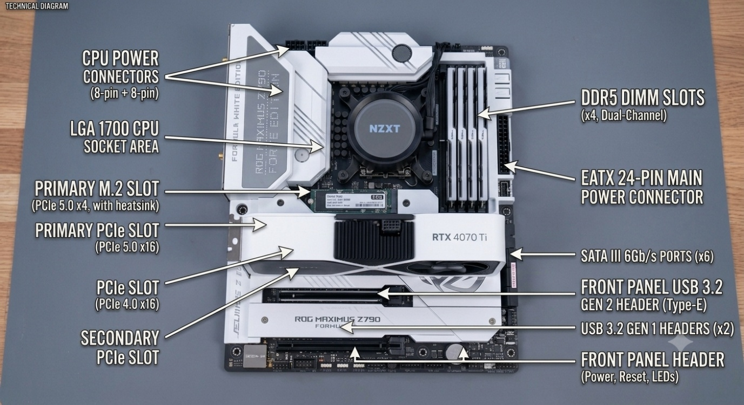
Figure : Labeled Diagram of a Motherboard Showing Major Components and Connectors.

Key Slots and Ports Identified

- CPU Power Connectors (8-pin + 8-pin): Dedicated power inputs to ensure stable voltage for the processor.

- LGA 1700 CPU Socket Area: The physical interface where the CPU is installed.

- DDR5 DIMM Slots (x4): Slots used for installing system memory in a dual-channel configuration.

- EATX 24-Pin Main Power Connector: The main port that provides power to the motherboard.

- Primary M.2 Slot (PCIe 5.0 x4): A high-speed interface for NVMe storage drives, featuring a heatsink.

- Primary PCIe Slot (PCIe 5.0 x16): The main expansion slot used for high-performance graphics cards.

- PCIe Slot (PCIe 4.0 x16): An expansion slot for additional hardware.

- Secondary PCIe Slot: A slot for further component expansion.

- SATA III 6Gb/s Ports (x6): Standard ports used to connect storage devices like HDDs and SSDs.

- Front Panel USB 3.2 Gen 2 Header (Type-E): Connector for front-chassis USB ports.

- USB 3.2 Gen 1 Headers (x2): Connectors for additional front-panel USB functionality.

- Front Panel Header: Interface for the cabinet's power button, reset button, and status LEDs.

TASK 2.
- Research and list 3 popular CPU socket types (for example: LGA1700, AM4, AM5) and name one compatible CPU model for each.

- CPU sockets define the physical and electrical interface between the processor and the motherboard. For a system to boot, the CPU's contact layout must match the motherboard's socket specification exactly. The following table identifies three widely utilized socket architectures and their respective compatible processors:

CPU Socket Type | Architecture | Compatible CPU Model
LGA 1700 | Intel (12th/13th/14th Gen) | Intel Core i9-14900K
Socket AM4 | AMD (Ryzen 1000 – 5000 Series) | AMD Ryzen 7 5800X3D
Socket AM5 | AMD (Ryzen 7000/8000/9000 Series) | AMD Ryzen 9 7950X

Technical Summary:

- LGA 1700 (Land Grid Array): Utilizes 1700 protruding pins on the motherboard to make contact with the CPU's flat pads; standard for modern Intel desktop performance.

- Socket AM4 (Pin Grid Array): Features holes in the socket to receive pins located on the underside of the CPU; renowned for its long-term platform support and backward compatibility.

- Socket AM5 (Land Grid Array): A transition to LGA-style connectivity for AMD, supporting modern DDR5 memory and PCIe 5.0 high-speed standards.

TASK 3.
- Explain in your own words the primary functions of the CPU and the chipset on a motherboard, and describe how they work together when you open a music app like Spotify.

- Functions of CPU and Chipset and Their Working Together (Spotify Example) :

- CPU (Central Processing Unit): The CPU is the main processing unit of a computer. It executes instructions, runs applications, and performs calculations required for the system to work properly.

- Chipset: The chipset is a group of components on the motherboard that manages communication between the CPU, RAM, storage, and other hardware devices. It helps all parts of the computer work together efficiently.

- Working Together (When opening Spotify): When we open Spotify, the CPU processes the instructions required to run the application. The chipset helps transfer data between storage, RAM, and the CPU, allowing Spotify to load smoothly and play music without interruption.

TASK 4.
- Find a clear photo of a real motherboard (from the internet or your own device), and identify at least 5 different ports or slots by circling them and labeling each one.

- Motherboard Component Identification :
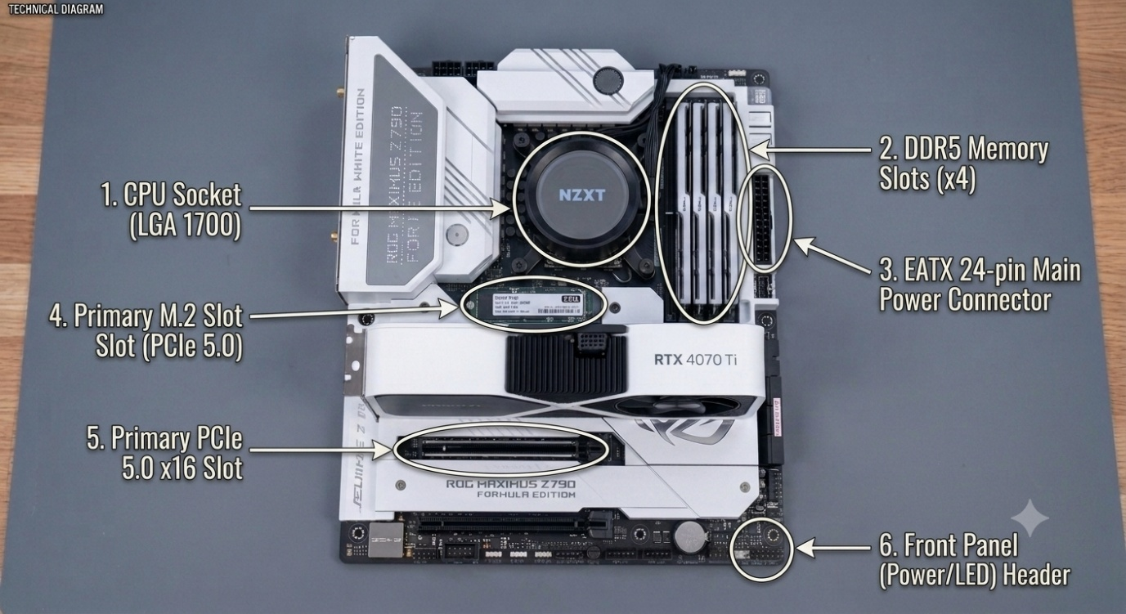
Figure : Labeled motherboard showing important ports and slots such as CPU socket, RAM slots, power connector, M.2 slot, PCIe slot, and front panel header.

Component Overview & Functional Breakdown:

- CPU Socket (LGA 1700) Function: It is the place where the processor is installed. It connects the CPU with other important components and allows the computer to perform calculations and tasks.

- DDR5 Memory Slots Function: These slots are used to install RAM modules. RAM provides temporary storage and helps the computer run multiple applications smoothly.

- EATX 24-pin Main Power Connector Function: It provides power from the PSU to the motherboard and its connected components.

- Primary M.2 Slot (PCIe 5.0) Function: It is used to install high-speed NVMe SSDs, which help in faster data transfer and quicker system performance.

- Primary PCIe 5.0 x16 Slot Function: It is mainly used for installing a graphics card (GPU). It provides high-speed connection for gaming, graphics, and other heavy tasks.
- Front Panel Header Function: It connects cabinet buttons like power and reset switches, along with LED indicators, to the motherboard.

